|  |
| --- |
|  |
| **Instructions for Using ELAN Annotation Software** |
|  |
| **Linguistic and Assistive Technologies Laboratory** |
| **10/8/2015** |
| **Version 5** |

|  |
| --- |
| This document is intended to be used as a guide to individuals annotating American Sign Language videos using the ELAN Annotation Software. The following is meant to be read as a step by step guide and is specific to the LATLab study on Immediate Feedback to Support Learning American Sign Language through Multisensory Recognition. |

**Table of Contents**

Collecting Videos from Participants 4

Preparing for Recording 4

Recording the Videos 4

Selecting the Best Videos for Annotation 4

Preparing a Video for Annotation 5

Installing Xilisoft 5

Using Xilisoft 5

Installing the ELAN Video-Annotation Software: 7

Mac Installation of ELAN: 7

Getting to Know ELAN: 8

Starting a New Annotation File for a Video: 9

Brief Instructions 9

Detailed Instructions 9

Open an Existing Annotation File for a Video 10

Associating .eaf Files with ELAN in Windows 10

Using a Second Monitor with ELAN 10

Navigating Through a Video: 11

Adding Annotations: 12

Sequence of Steps for Linguistic Annotation: 14

Signing Happening 14

Clauses 14

Glosses 14

Timing of Glosses 14

Labels for Glosses 14

Fingerspelling 15

List of Wanted Words: 15

Labeling Facial Expressions 17

Aligning Annotations of Glosses and Facial Expressions 17

Labeling All, Correct, and Incorrect Facial Expressions 17

Different Types of Facial Expressions 18

Non-Manual: NEG 18

Non-Manual: WHQ 19

Non-Manual: YNQ 20

Non-Manual: RHQ 21

Non-Manual: COND 22

Non-Manual: TOPIC 24

Lexical Point 25

Numbers 25

Correct Timephrase 25

Mouth Morhpeme 25

Correct Roleshift 26

Error Point Gaze 26

Summary Annotations 27

Complete Listing of Tiers: 28

Tier Descriptions 29

Appendix 1: ELAN Annotation Format (EAF): 31

XML Schema description: 32

Appendix 2: Video File Naming Conventions 37

Appendix 3: LATLab Folder Naming Conventions and Storage Plan 38

# Collecting Videos from Participants

## Preparing for Recording

Before converting or annotating videos, you must collect the videos from the participants. After recruiting a participant and determining a meeting time, it is important to make sure that all the necessary paperwork is printed and ready to be used. At least an hour before the test session you should make sure that the hardware and software needed for recording is working properly and that the lab is properly set up.

## Recording the Videos

Before recording the video you should remind the participant to begin and end each video with their hands on their lap. This way it will be clear when signing begins and ends (this will be important later). Also, check to make sure that the participant is not wearing anything that covers their face or that could be distracting while signing (bracelets, necklaces, etc.). Before the participant leaves, make sure that the videos have been recorded properly. If there are sections of the video in which the recording software has dropped multiple frames, it may be beneficial to rerecord the video. Even a few dropped frames can drastically affect how successful video annotation will be.

**Organizing the Videos**Once a set of videos has been recorded, they should be organized on the computer connected to the Kinect camera. Separate folders should be set up for each homework assignment and within them should be folders for each participant. Select only the best videos from each utterance and move them to the appropriate folder within the recordings folder. Once the videos are properly organized on the computer, copy the participant’s folder and place it in the same location on the external hardrive. The external should also have folders for individual homework assignments with individual participant’s folders within them.

## Selecting the Best Videos for Annotation

Frequently participants will be able to tell which take was their best purely from an ASL standpoint, however, this may not always be the best take to choose to annotate. Depending on the specific study, it may be very important to use the take with the most fluent ASL, but the quality of the video also matters. If the participant looks down or masks their face with their hands, the video may not be as useful as one with slightly choppier ASL but with no other quality issues. Once again this depends on the study and you should check with Matt before making the decision to include a less fluent take.

# Preparing a Video for Annotation

Before a video is opened in ELAN it should be converted so that it conforms to certain specification (shown below), to ensure that the video quality and framerate are consistent throughout all videos.

## Installing Xilisoft

The conversion software that we will be using for this project is called **Xilisoft Video Converter Ultimate**, it can be found at: <http://www.xilisoft.com/video-converter-software.html>. Follow this link and click **download** next to the operating system that you are using. Once the download is complete a setup wizard will pop up, follow the wizard to download the software.

**Note:** Registering the Xilisoft software allows the user to convert videos that are five minutes or longer. You can process videos that are shorter than five minutes without registering.

## Using Xilisoft

Once the software has been opened you must select a video to convert. In order to select a video click the “+” icon in the top left corner and select the video that you wish to convert using the dialog box which appears. Once you select a video it will show up in the white space in the middle of the software’s GUI. You can select more than one video to convert at a time, however, converting too many videos at once may take a long time to convert and will likely use all of your computer’s CPU resources for a time. Once all of the videos have been added click the icon in the top right corner that looks like this: . This will open up the advanced settings for the profile. Change the settings so that they match the image below, which shows the correct advanced settings for converting videos on a Mac. The Windows version of the software will not have as many options, but you should still try to match these settings to the best of your ability:

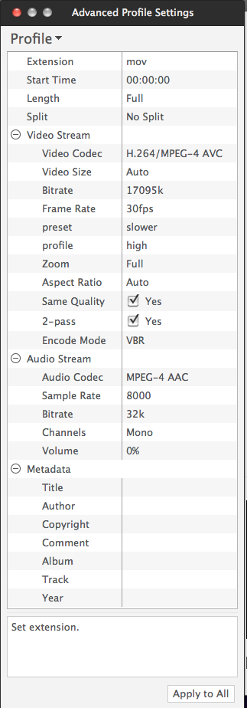

Once the settings have been changed, click the Start button to begin converting the videos. If the profile settings have been entered correctly the resulting videos should be Quicktime video files (.mov) with smooth high quality video.

**Note:** All of the settings above can be typed in manually by double clicking on the current value. Some of the values shown are not preset values in Xilisoft: It is not possible to select them from a drop-down list of choices. To enter those values, you must manually type them in this way.

# Installing the ELAN Video-Annotation Software:

When you are ready to begin linguistically analyzing videos, then you should install ELAN on your working computer. The LATLab has 1 computer with ELAN installed on it, the 5K IMac, and there is another IMac with ELAN installed on it inside of CAIR.

To download the software to a new computer, you can find the installation files for Mac, PC, and Linux at the following address: <https://tla.mpi.nl/tools/tla-tools/elan/download/>. **Current Version: 4.8.1 or better**

## Mac Installation of ELAN:

Mac users will need to download Java for OS X before installing ELAN. Java for OS X can be found here: <https://support.apple.com/kb/DL1572?locale=en_US>.

**PC Installation of ELAN:**

On Windows computers the newest version of ELAN (July, 2015) does not work with the newest version of QuickTime for Windows. In order to use ELAN, Windows users must uninstall QuickTime (if they already have it downloaded) and use an older version of QuickTime for windows (version 7.6) which can be found here: <https://support.apple.com/kb/DL762?viewlocale=en_US&locale=en_US>. The Language Archive website also states that ELAN must be installed **AFTER** the appropriate version of QuickTime has already been installed, so if you need to change which version of QuickTime you are using you may have to reinstall ELAN afterwards.

Compatibility problems may also occur when attempting to open an ELAN file that was created on a Mac computer. As these compatibility problems can cause issues later on with analyzing the annotations, it’s suggested to use the Mac version of ELAN. The PC version is still fine as long as it’s equal to or better than the current version, but it is necessary to do one additional step in annotating. Before saving the annotation files to the dropbox, it is necessary to open them in a Mac ELAN, validate the file runs correctly without issues , then save it on the Mac and upload it to the dropbox.

# Getting to Know ELAN:

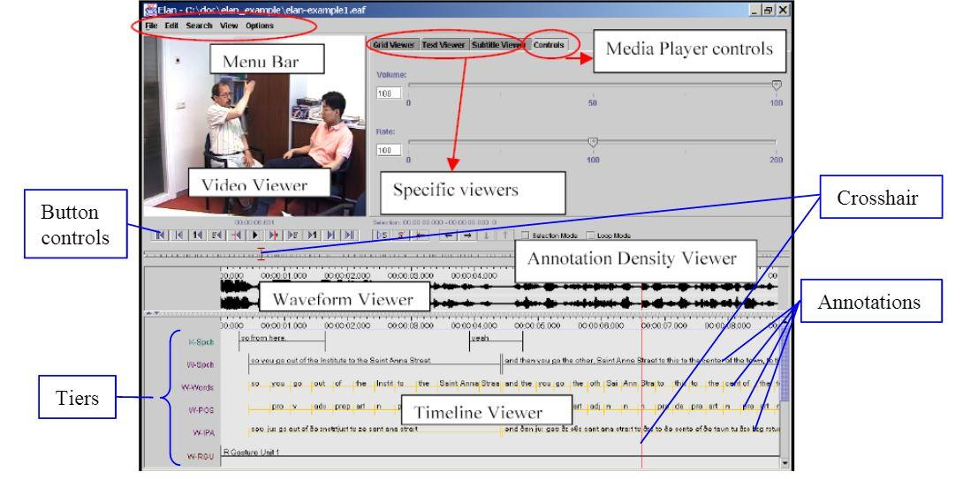

1. The Annotation Density Viewer represents the whole video from beginning to end.
2. The Timeline Viewer shows just one portion of the video.   
   You can zoom-in or zoom-out by right-clicking on this viewer and choosing “Zoom”.
3. The Timeline Viewer also shows annotations arranged on different lines, called TIERS.   
   Each tier contains a different type of annotation, such as a section label, a free translation, a gloss, a grammatical label, or a phonological feature such as eye blink or body shift.
4. The video viewer shows the current frame of the video.
5. The location of the current frame is indicated in the Annotation Density Viewer and the Timeline Viewer by the CROSSHAIR, a red vertical line or I-bar.
6. The Grid, Text, and Subtitle Viewers provide alternative ways of viewing annotations on particular tiers; they are explained later.
7. For work with sign languages, you probably won’t work with or even see the waveform viewer (which is for audio).

# Starting a New Annotation File for a Video:

When you provide linguistic annotations for a video, ELAN will save this information inside an annotation file (.eaf), which is associated with a video file. In the process of annotating a video, all changes are recorded in the annotation file; the video file is left unchanged.

## Brief Instructions

To start a new annotated video, open ELAN, select File, and click NEW. This will open a file-browsing window with options to add a media file and a template. Add the appropriate media file and provided master template named **masterTemplate.etf**, when both files have been added click OK. The video will then open with the template beneath it.

Detailed instructions are included below for how to start a new annotation file for a video.

## Detailed Instructions

To start a new annotation file, do the following:

1. Start ELAN (e.g. in Windows, use a shortcut on the Start Menu or on the Desktop).
2. Choose “File, Open” (Ctrl+N). Now, you should select a video file to annotate.   
   * 1. Use “Look In” if necessary to change folders.
     2. A video that is ready to be annotated will have a .mov extension. If they video you want to annotate does not have a .mov extension then the video was not converted properly (see **Preparing a video for annotation**).
     3. Select the file, and then copy the file’s name to the right-hand list.
     4. If you have more than one video file of the same event (e.g. one camera from the front and one from the side), you can add up to a total of four videos to the list.
3. Optionally, choose a template. A TEMPLATE is a special ELAN annotation file, an “empty shell” that contains a setup for doing annotations in a particular way, but without any annotations or attached media files. It saves a lot of work to base a new annotation file on a template, and makes it easier to annotate several videos in the same way. For our project at the LATLab, we’ll use a template called **masterTemplate.etf**
4. Under “Select”, choose “Template”.   
   Use “Look In” if necessary to change folders.   
   Select a template (.etf) file, then choose it to add it to the right-hand list along with the media file(s).
5. Choose “OK” to create the annotation file. Be patient; this can take a few seconds.
6. I suggest you save the new file immediately using “File, Save As”.

# Open an Existing Annotation File for a Video

1. Start ELAN.
2. Use “File, Open” (Ctrl+O) to locate and open the ELAN annotation (.eaf) file.

## Associating .eaf Files with ELAN in Windows

In Windows, you can also start ELAN by double-clicking on an .eaf file in Windows Explorer, once you have associated the .eaf file type with ELAN.

If the installer for ELAN hasn’t done this for you, you can do it yourself:

* 1. Right-click on an .eaf file in Explorer, and choose “Open with...”.
  2. If Windows asks whether to use the Web service to find the appropriate program, choose “Select the program from a list” and then “OK”.
  3. You will probably not find ELAN in the list that is presented; you will need to use Browse to find it on your hard drive. Usually it is installed under “c:\Program Files\Elan 2.4.2” (the exact location may vary). Select “Elan.exe” and choose “Open” to close the browsing dialogue box. Then, in the main “Open With” dialogue box, check the box that says “Always use the selected program to open this kind of file”, and “OK”. After you’ve done that, you should be able to just double-click on an .eaf file to open it in ELAN.

# Using a Second Monitor with ELAN

While creating annotations, it may be easier to use a second computer monitor. It is possible in ELAN to position your video on one monitor and to view your annotations on a second monitor. Right-clicking the video in the top left corner will give the user the option to detach the video. The video can then be placed on a second screen, making it easy to see the video in detail as well as several annotation tiers.

# Navigating Through a Video:

While watching the video the user can move forward and backward through the video at .033 second intervals by holding command (Mac) or control (PC), and pressing the right or left arrow keys. There is also a status bar under the video which can be dragged and moved to different locations in the video.

1. To stop and start the video, use Ctrl+Space or the play/pause button on the user-interface.
2. To set the position of the crosshair (so you can see a different frame in the Video Viewer), click with the mouse any place in the Timeline Viewer which does not have an annotation (e.g. on the time codes at the top edge of the viewer), or anyplace in the Annotation Density Viewer.
3. To set the position of the crosshair more precisely, use the button controls or keyboard shortcuts.   
   1. Move to the beginning (Command+B) or end (Command+E) of the video.
   2. Move 1 scrollview backward (Command+PageUp) or forward (Command+PageDown).
   3. Move 1 second backward (Shift+Left) or forward (Shift+Right).
   4. Move 1 frame backward (Command+Left) or forward (Command+Right).
   5. Move 1 “pixel” backward (Command+Shift+Left ) or forward (Command+Shift+Right).
   6. Move to a specific location (in minutes and seconds) using “Search, Go To”.

# Adding Annotations:

In order to add an annotation for a sign, click the location on the timeline where the sign starts and drag the annotation to the right until the sign ends. Double click the annotation to add a label (in some cases, the “template” for your annotation will constrain the set of possible labels to a finite list).

1. Select a tier to work with as the “Active Tier”. The easiest way to do this is to double-click on the name of the tier, at the left side of the Timeline Viewer. The name of the active tier will be underlined, red and bold. When a portion of the video is selected, the shading of the active tier inside the selection is pink rather than blue. The active tier is the one that normally receives new annotations.

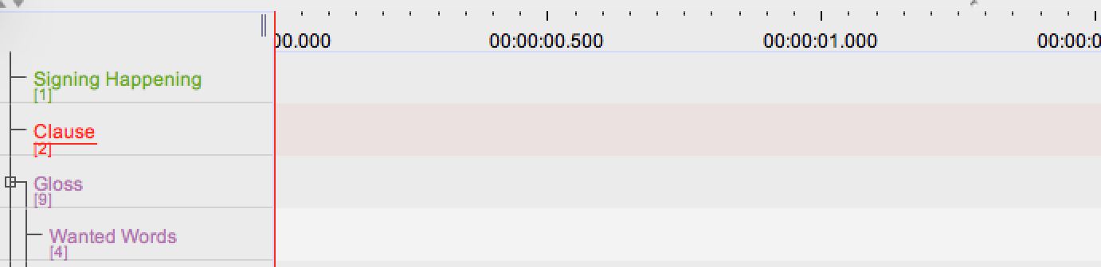

“Clause” is the active tier

1. Select a segment of the video to annotate. Although you can click and drag the mouse to do this, you often will want to set the selection with more precision. That’s what Selection Mode is for.   
   1. Set the crosshair at one end of where you want the selection to be.
   2. Clear any selection (Shift+Option+C).
   3. Make sure Selection Mode is on (Command+K).
   4. Move the crosshair in small increments using the button controls or keyboard shortcuts (see above); as the crosshair moves, it will move either the beginning or end of the selection with it.
2. Once you have one end of the selection where you want it, you can switch the crosshair to the other end or (Command+/) and adjust that end too.   
   1. When you have the whole segment selected that you want to annotate, either type Option+N (not Command+N), choose “Edit, New Annotation Here”, or right-click on the selection at the height of the active tier and choose “New Annotation Here”. A box will open up inside the selection on the active tier; type some text into it. When you are done, type Command+Enter. (Warning: If you click someplace else without typing Command+Enter or otherwise committing the changes, you will lose the information you entered.) To modify the text of an existing annotation, first make it active (e.g., by clicking once on it, or as described above).
3. To change the text of the annotation, type Option+M, choose “Edit, Modify Annotation Value”, or right-click on the active annotation and choose “Modify Annotation Value”. Depending on how you do it, you’ll either get the same type of box that you used when first making the annotation, or a larger box in a separate window. In either case, make your changes, and then type Command+Enter to commit them.
4. If after starting to make changes to an annotation, you change your mind and want to revert to what you had before, type Escape.  
   1. You can also modify the text of an annotation without first making it active. Double-click on it in the Timeline Viewer, Text Viewer, Grid Viewer, or Subtitles Viewer. An editing box of some sort will open up (either in the viewer or in a separate window). Annotations can then be typed within the editing box. Remember to type Ctrl+Enter when you are done to commit changes.

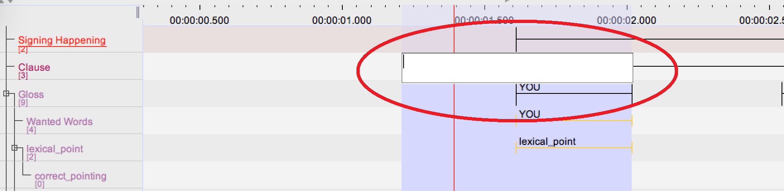

Double-clicking opens editing box

* 1. To move one or both ends of the annotation, make it active (e.g. by clicking once on it), turn on Selection Mode (Command+K), and switch the crosshair to the end of the selection that you want to adjust (Command+/). Then move the crosshair (with button controls or keyboard shortcuts) and that end of the selection will move with it. When done, type Command+Enter, or right-click on the annotation and choose “Modify Annotation Time”.
  2. To delete an annotation, first make it active. Then type Option+D, choose “Edit, Delete Annotation”, or right-click on the annotation and choose “Delete Annotation”.
  3. Even after you’ve completed a change, you can undo it; type Command+Z or choose “Edit, Undo...”.

# Sequence of Steps for Linguistic Annotation:

The recommended way to approach annotating videos for this project is to start with the most simplistic annotation tiers and gradually work toward the more specific and complicated tiers.

## Signing Happening

Before annotating anything else, it will likely be easiest to start with annotating whether or not the participant is signing at that moment. This is a very basic annotation and it will give you a good chance to watch the video before getting to the more detailed annotations.

## Glosses

Next you should annotate the glosses for each individual sign. While labeling the glosses it is recommended that you also look for lexical facial expression errors. If the glosses indicate that a certain facial expression should be used, but the signer does not use that facial expression, or uses a different facial expression, then this is a lexical facial expression error. Tiers exist for lexical errors relating to the absence of YNQ, WHQ, RNQ, Conditional, and Negative facial expressions.

### Timing of Glosses

The timing of these glosses should begin exactly when the sign is produced and end when the hand begin to fall or move into the position of another sign. The times in which the hands are moving into position to make a sign are not to be included as part of the gloss.

We do not count the anticipatory movements—while the hands get into the appropriate position to begin to articulate the sign in question—as part of that sign. Similarly, we have identified the end point of the sign as occurring prior to movement of the hands out of the position for that sign in preparation for articulation of the following sign. It is not always obvious where one sign ends and the next begin.

### Labels for Glosses

Gloss labels should consist of the English word that best represents the sign that is occurring at that time. We have attempted to use standard conventions for the nearest English equivalent to a given ASL sign. If the word can be found on the **List of Wanted Words** following this section, then spell it exactly as it is spelled on that list. If the word cannot be found on that list, then spell it the same way every time it is used. This English word is written in capital letters.

## Clauses

The clause tier should be annotated last, mark where clauses begin and end. Some sentences consist of more than one clauses. For example, “IF MARY GRADUATE, SHE LEAVE ROCHESTER” consists of two clauses “IF MARY GRADUATE” and “SHE LEAVE ROCHESTER.” Each clause contains a predicate (verb). It’s best to do this last in order to sync clauses with the glosses.

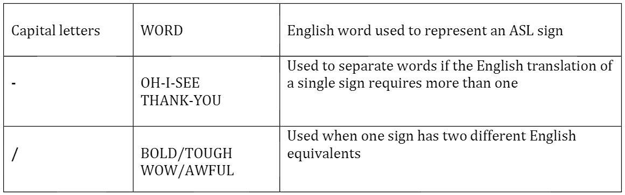

On occasion, however, you may encounter a sign for which there is no conventional gloss known to us (or to those with whom we have consulted). In such cases, you should do your best to find a reasonable gloss (and you should discuss this with Matt or with other students on the project). We should attempt to be ***consistent*** in using a single correspondence between ASL sign and English gloss throughout our transcriptions. In some cases, there may be two close variants in ASL that would be roughly translated by the same English word.

### Fingerspelling

If finger spelling occurs at any point during the video, the duration of the fingerspelling should be annotated on the **Fingerspelling** tier. Once you’ve annotated the occurrence of fingerspelling, it is time to look for fingerspelling errors. Tiers exist for fingerspelling errors related to weird or illegal handshapes used during fingerspelling (**error_fingerspell_hand**), weird or non-standard location of the hand during fingerspelling (**error_fingerspell_loc**), unnecessary or non-standard movement of the hand during fingerspelling (**error_fingerspell_move**), and non-fluent speed of fingerspelling (**error_fingerspell_spee**). If fingerspelling occurs without errors, then this should be represented under the **correct_fingerspell** tier.

### List of Wanted Words:

The following is a list of glosses that may be used more frequently than some others. As previously stated all signs should have a gloss created for them whether or not they are included in the list below. Anytime one of the following words occurs, an annotation should be created under the **Wanted Words** tier.

AGE QUESTION

AGE_NUMBERS

APRIL

AUGUST

AFFIRMATICE_SIGNS

CANNOT

CARDINAL_NUMBERS

DECEMBER

DODO

DOLLAR_NUMBERS

FEBRUARY

FIVE OF US

FOUR OF US

FRIDAY

HE

HOW

I

IF

JANUARY

JULY

JUNE

LASTYEAR

MARCH

MAY

ME

MINE

MONDAY

MY

NEXT

NO

NONE

NOT

NOVEMBER

NOW

NO_ONE

NEGATIVE SIGNS

OCTOBER

OIC

ORDINAL_NUMBERS

PREVIOUS

QMWG

SATURDAY

SEPTEMBER

SHE

SINCE

SUNDAY

THEM

THEY

THREE OF US

THURSDAY

TIME_NUMBER

TPDAY

TOMORROW

TUESDAY

WANT

WE

WEDNESDAY

WHAT1

WHAT2

WHEN

WHERE

WHICH

WHO1

WHO2

WHY1

WHY2

WILL

YES

YESTERDAY

YOU

YOUR

# Labeling Facial Expressions

Now that you have labeled all of the glosses in the video, it is time to watch it again and label the corresponding facial expressions.

While this document uses the term “facial expressions,” the signer is actually using more than the face. Most of these “facial expressions” also include head movement. For example, the head shakes left and right during NEG (negation) facial expressions. As another example, the head tilts during TOPIC facial expressions. Often the head movements will be easier to see than the subtle face changes.

## Aligning Annotations of Glosses and Facial Expressions

Typically the facial expressions should line up on the timeline with the glosses, however, if the facial expression occurs significantly before or after the gloss then the labels should not line up.

* If a sign and a facial expression start at slightly different times in the video, but if they are linguistically meant to be expressed together, the you should align the corresponding annotations. For example, a “NEG” (negation) facial expression often occurs during an *entire verb phrase* in a sentence, e.g., in the ASL sentence “MARY NOT BUY HOUSE” we would expect the beginning of the NEG facial expression to start with the beginning of the word “NOT” and the end of the NEG facial expression to stop with the ending of the word “HOUSE.” If the movements of the signer’s head begin or end slightly before/after, it is OK to ignore such minor differences in synchronization. When you draw your annotations, you should line-up the beginning of the Negation with NOT and the ending of Negation with HOUSE.
* If the facial expression happens *significantly* before or after the corresponding sign then they should not lineup. For example, if you are annotating a video from a beginning ASL student, and the student is producing non-fluent ASL signing, then you might see such a misalignment occur. In such a case, your annotation of the NEG facial expression might not align with the beginnings or endings of the words that are signed.

## Labeling All, Correct, and Incorrect Facial Expressions

On the “FACE-” tiers of annotation, you will add an annotation for all facial expressions that you see, regardless of whether the facial expressions were used correctly or not. For example, if a signer randomly performs a NEG facial expression in a weird place during a sentence, you would still annotate this on the “FACE-NEG” tier.

In addition to the “FACE-” tiers, there are sometimes additional tiers where you need to add information to indicate that the facial expression has been performed correctly or incorrectly.

Sometimes, you will need to annotate that a facial expression has been incorrectly omitted, i.e., based on the lexical structure of the sentence, you know that it is “missing.” This applies to WHQ, YNQ, Conditional, and Negation, so keep an eye out for when they should occur.

# Different Types of Facial Expressions

The following sections will describe what a specific facials expressions look like.

At the end of each section, there are bullet points with “if” statements to help you decide what to do if this facial expression occurs.

## Non-Manual: NEG

Is the signer’s head shaking left-to-right as in a negative manner? The non-manual marking for negation generally consists of a side-to-side headshake.

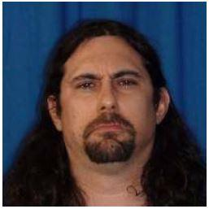

Negative headshake (example from Neidle, et al., 2000)

Typical elements of this performance include:

* + - * 1. shake head from side-to-side (greatest amplitude at the beginning of the phrase)
        2. slightly furrowed eyebrows
        3. slightly scrunched nose
* If the signer performs the correct face and head movements for a NEG facial expression, then this should be annotated under the **FACE_NEG** tier (regardless of whether it was used correctly or not in the sentence).
* If this NEG facial expression has been used correctly, then this should also be annotated under the **correct_neg** tier.
* If the lexical structure of a sentence suggests that a **NEG** facial expression should have been used, but the signer did not perform it, this should be annotated under the **error_neg_lexical** tier. For example, if the signer says “MARY NOT BUY HOUSE” but does not perform a NEG facial expression, then you should label the word “NOT” on the **error_neg_lexical** tier.

## Non-Manual: WHQ

Is the signer making WH-question facial expressions? Typically, the signer furrows his eyebrows and tilts head forward when asking a question (and/or tilting head a bit to the side).

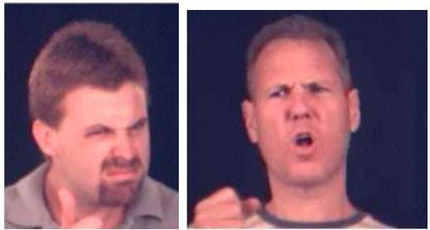

WH-Question marking (example from Neidle et al. 2000)

Typical elements of this performance include:

* + - * 1. maintain eye contact
        2. furrowed eyebrows
        3. tilt head forward
        4. (lean forward)
* If the signer performs the correct face and head movements for WHQ facial expression, then this should be annotated under the **FACE_WHQ** tier (regardless of whether it was used correctly or not in the sentence).
* If this expression has been used correctly, then this should also be annotated under the **correct_whq** tier.
* If the lexical structure of a sentence suggests that a **WHQ** facial expression should have been used, but one does not occur, this should be annotated under the **error_whq_lexical** tier. For example, if the sentence says “YOU WANT WHAT” but there is no WHQ, then you should label the question word (“WHAT”) on the **error_whq_lexical** tier.

## Non-Manual: YNQ

Is the signer making a yes/no question facial expression?

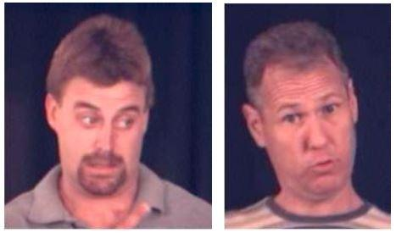

Yes-no question marking (example from Neidle et al., 2000)

Typical elements of this performance include:

* + - * 1. maintain eye contact
        2. raised eyebrows
        3. tilt head forward
        4. (lean forward)
* If the signer performs the correct face and head movements for a YNQ facial expression, then this should be annotated under the **FACE_YNQ** tier (regardless of whether this facial expression was used correctly during this sentence).
* If this expression has been used correctly, then this should also be annotated under the **correct_ynq** tier.
* If the lexical structure of the sentence suggests that a **YNQ** facial expression should have been used, but one does not occur, this should be annotated under the **error_ynq_lexical** tier. NOTE: You should be very conservative with the error_ynq_lexical tier. You should only label this type of error if there is a specific word that clearly indicates that it is a yes-no question. For example, is there a “Question Mark (wiggle)” sign at the end of the sentence?
* If a **YNQ** facial expression begins but is too far from the beginning of a clause, then this should be annotated under the **error_ynq_beginning** tier.
* If a **YNQ** facial expression ends but is too far before or after the end of a clause, this should be annotated in the **error_ynq_end** tier.

## Non-Manual: RHQ

Is the signer asking a rhetorical question? (The signer often uses “why” or “who” or “what” in the middle of sentence often replacing “because” from the English sentence but then quickly answering the question himself (e.g. ASL version: “I LOVE MOVIES, WHY?, THEY FUN WATCH” while the English version would state “I love movies because they are fun to watch.”)

Rhetorical question often includes raised eyebrows and tilted head to indicate explanation of why a specific thing happened. For example: “My mom got in an accident, WHY?, it was raining outside.” Rhetorical questions can include “how,” “why,” “who,” “what,” “when,” “where.”

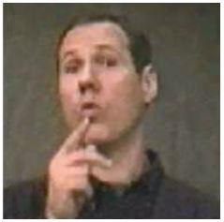

Rhetorical WH-Question Marking (example from Neidle et al., 2000)

Typical elements of this performance include:

* + - * 1. maintain eye contact
        2. raise eyebrows
        3. tilt head slightly forward
        4. (hold the last sign or the question longer)
* If the signer performs the correct face and head movements for a RHQ facial expression, then this should be annotated under the **FACE_RHQ** tier (regardless of whether the signer used it correctly during this sentence).
* If this facial expression has been used correctly, then this should also be annotated under the **correct_rhq** tier.
* Sometimes you may notice that the words in a sentence suggest that a signer should have used a rhetorical question, but the signer did not perform one. For this project, we are NOT annotating this type of error. So, there is no place for you to annotate this type of error.

## Non-Manual: COND

Is the signer making the facial expression for a conditional “if” or a “when” clause at the start of a sentence? The signer may emphasize the “if” or “when” often with eyebrows and some side/backward head tilting, such as: ASL: “1988, I BORN” English: “In 1988, I was born.” ASL: “MARY GRADUATE, LEAVE ROCHESTER.” English: When Mary graduates, she’ll leave Rochester. During the phrases “1988” or “MARY GRADUATE” there is a COND facial expression.

The COND facial expression can also convey the idea of “if.” It is optional for the signer to use the ASL sign “IF” in the sentence. The COND facial expression is what’s important. For example: “YOU BREAK, YOU BUY” can mean “if you break it, you buy it” if the signer performs a COND facial expression during the phrase “YOU BREAK.” Other times, you may see the signer perform the word “IF”, for example: “IF YOU BREAK, YOU BUY.” In this example, the signer would perform the COND facial expression during the phrase “IF YOU BREAK.”

Sometimes, signers actually use the sign “IF” or “WHEN.” Sometimes they don’t.

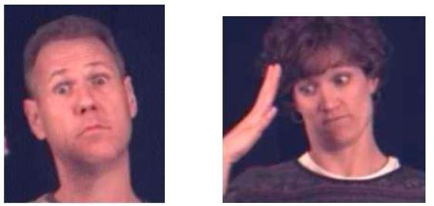

COND facial expression during an if-sentence COND facial expression during a when-sentence

(examples from Neidle et al., 2000)

Traditionally, some ASL linguists have claimed (Coulter, 1979, e.g.) that the COND facial expression during ‘when’ or ‘if’ clauses is actually the same as the TOPIC marking described below. This may be true. At the very least, the two facial expressions (COND and TOPIC) are extraordinarily similar, although native signers seem able to distinguish between the conditional and when clauses based solely on the non-manual expression (with eye gaze perhaps being key).

Also, often an entire clause will go underneath the COND facial expression:

**cond**

IF fs-JOHN ARRIVE fs-MARY WILL LEAVE

**cond**

fs-JOHN GRADUATE FAMILY PLAN PARTY

Typical elements of this performance include:

* + - * 1. eyebrows are raised
        2. head is tilted slightly
        3. (slight body shift to the dominant side for the conditional part of the sentence)
* If the signer performs the correct face and head movements for a COND facial expression, then this should be annotated under the **FACE_COND** tier.
* If this expression has been used correctly, then this should also be annotated under the **correct_cond** tier.
* If the words in the sentence suggest that a **COND** facial expression should have been used, but one does not occur, this should be annotated under the **error_cond_lexical** tier. NOTE: You should be very conservative with the error_cond_lexical tier. You should only label this type of error if there is a specific word that clearly indicates that it is a yes-no question. For example, is there a “IF” sign at the beginning of the sentence? Is there a time-word (e.g., “MONDAY” or “NEXT-WEEK”) at the beginning of the sentence?
* If a conditional facial expression begins too far before or after the beginning of the clause that the facial expression is associated with, then an annotation should be created under the **error_cond_beginning** tier.

## Non-Manual: TOPIC

This facial expression occurs during words or phrases that occur at the beginning of clauses and establish a topic for discussion. This facial expression is frequent in ASL signing.

NOTE: When annotating videos, many people accidentally mix-up the COND and the TOPIC facial expressions. The “topic” and the “cond/when” facial expressions can look similar. It may be easiest to consider the meaning: If the facial expression means “if” or “when” then use the COND label. If the expression means “regarding” or “as for,” then use TOPIC.

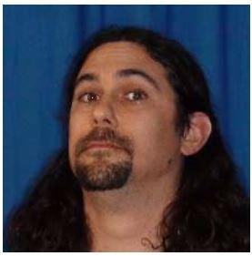

Typical elements of this performance include:

* + - * 1. widen eyes
        2. raised eyebrows
        3. backward shift
        4. (slight hold on the sign or signs that is being topicalized)
* If the signer performs the correct face and head movements for a TOPIC facial expression, then this should be annotated under the **FACE_TOPIC** tier.
* If this expression has been used correctly, then this should also be annotated under the **correct_topic** tier.
* The **error_topic_beginning** tier should receive an annotation if the topic facial expression begins too far before or after the beginning of the clause that the facial expression is associated with.
* Sometimes you may notice that the words in a sentence suggest that a signer should have used a TOPIC facial expression, but the signer did not perform one. For this project, we are NOT annotating this type of error. So, there is no place for you to annotate this.

# Lexical Point

Now annotate any lexical pointing that occurs in the video under the **lexical_point** tier. Lexical pointing occurs when the signer is setting up a location in the signing space to represent a person, thing, or concept under discussion. Lexical pointing also occurs whenever the signer refers to that location again. Sometimes, we think of lexical pointing as if it is a “pronoun” like he, she, it, they, etc.

* Whenever the signer performs the correct hand movements to “point” to a location around their body in the signing space, then you should label this on the **lexical_point** tier, regardless of whether it was used correctly during a sentence.
* If the signer has *correctly* performed lexical pointing, then you should also annotate this under the **correct_pointing** tier. For example, if the signer randomly points to some location around their body, but it does not make sense, given the meaning of the sentence, then this should not be annotated on the **correct_pointing** tier.
* If the signer is setting up the lexical point with an index point; The gloss is ix_R or ix_L depending on the hand used to set up the point.

# Numbers

Anytime a number is signed it should be annotated under the **Numbers** tier. You can look for numbers at any stage during the annotation process.

# Correct Timephrase

We would like to identify times when the signer correctly sets the time for a sentence in the following manner: The signer has correctly: (1) used a time-related sign at the beginning of a clause AND (2) they have simultaneously used a COND facial expression.

* When the signer has *correctly* done both of these things at the same time, then you should annotate this under the **correct_timephrase** tier.
* If the signer has done any of this incorrectly, then you should NOT annotate anything on the correct_timephrase tier.

# Mouth Morhpeme

Now it is time to look for mouth morphemes. An example of a mouth morpheme is the mouthing of the sound “cha” when using the sign for large or huge. Several of these morphemes are supposed to occur simultaneously with various signs.

* Whenever the signer performs the correct face movements for a mouth morpheme, you should annotate this occurrence under the **MOUTH_MORPHEME** tier, regardless of whether it was used correctly or not.
* If it is used correctly, then you should also create a matching annotation on the **correct_mouth_morphem**e tier.

# Correct Roleshift

You should look for any occurrences of roleshift during the video. A roleshift occurs when the signer switches from describing one object to describing a different object by assuming the identity of the object. This is characterized by a rotation of the torso (and typically the signer’s eye-gaze will aim at a different location when their torso is shifted).

One use of roleshift is in narrative story-telling situations. For example, a signer may “become” characters in a story, and shift their torso as they play the role of each character. If a signer wants to repeat information that someone said, the signer may also use roleshift to “become” the person, and then sign what that person said.

Another use of roleshift is when a signer is comparing or contrasting two things. Often, the signer will shift their torso left or right, as they refer to each item that they are contrasting. In this case, the signer will associate one item with their left side, and one item with their right side.

Roleshift is to be annotated for the duration of the torso movement, indicating that they are changing between topics.

* If roleshift has been used *correctly*, then you can annotate under the **correct_roleshift** tier.
* If roleshift has been used incorrectly, then should NOT annotate anything. For example, if the signer moves their torso (but there is no linguistic meaning to this movement), then you should not annotate this. The same also applies for if the signer should have moved their torso based on the sentence; If they don’t move, then it’s not a roleshift. There is nothing to annotate.

# Error Point Gaze

We would like to identify errors that signers make where there is a mismatch between their lexical pointing and their eye-gaze. Search through the video and annotate any instance in which the signer does ANY of these three things:

* The signer gazes in a specific direction without a simultaneous lexical pointing, or
* The signer does a lexical pointing without gazing in the same direction, or
* The signer performs a lexical pointing in one direction and they gaze in a different direction.

If any of these three things occur, then we consider this to be an error.

* If ANY of these three types of errors occur during a video, you should annotate this under the **error_point_gaze** tier.

# Summary Annotations

In this project, we use the term “summary” to refer to errors that signers make across the entire video or across long phrases. Thus, you need to look at a longer span of the video in order to decide if such an error has occurred during the ASL performance.

These “summary” errors consist of: **hands_down**, **signing_pauses**, and **signing_large**.

**signing_large:** Is the signer using too large a signing space?

**signing_pauses:** Is the signer pausing too much during the signing?

**hands_down**: Is the signer putting their hands down too   
frequently during the signing?

Since these three categories rarely occur, it may make sense to look for all three of these at once.

Of course the **signing_large** category can occur at any time, however, the **hands_down** and **signing_pauses** categories should only be considered if the signer has paused or dropped their hands for a *significant amount of time during the time they were signing*. This has to do with how quickly they were signing previously and whether or not the content of the sentence called for a natural pause. If signers pause or put their hands down in a manner that looks fluent or natural, then this is NOT an error, and you should NOT label it. This also includes the start and end of the video; **hands_down** should not be annotated at the end of the video when the signer has completed everything they have to say. The summary-tiers should only show up within the signing-happening range, anything outside of that is part of the recording process and does not contain any meaningful data.

Since these errors may occur during several signs or during the entire video, you must decide the time-range for these annotations that reflects the portion of the video where you see this error happening.

One thing that may help with annotating these tiers is to think of what a fluent signer would do in such a case. If a fluent signer would not use such a large space, then mark it as **signing_large**. The same goes for the pauses/hands_down, consider if a fluent signer would actually do such a thing.

# Complete Listing of Tiers:

The image below contains a full listing of the tiers inside ELAN for this project.

On the next page, you will find descriptions of each of these tiers.

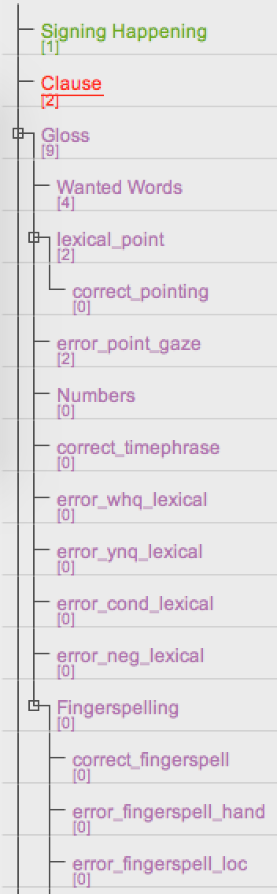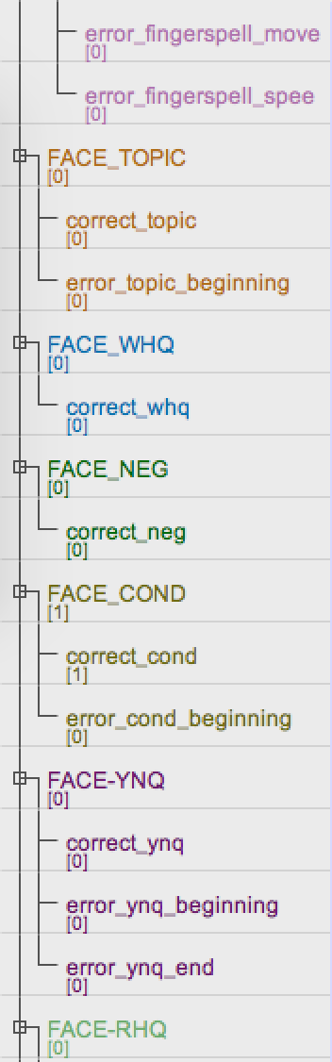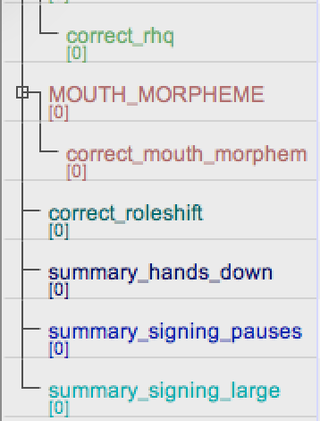

# Tier Descriptions

1. **Signing Happening** – Start with this tier, label where the signing begins and ends (pg. 11).
2. **Clause** – Label where the clauses begin and end (pg. 11).
3. **Glosses** – In this section your annotations should consist of English words that match each sign performed in the video (pg. 11).
   1. **Wanted Words –** Anytime a word from the special list of words (pg. 12) occurs, an annotation should be created under this tier.
   2. **Lexical Point –** Lexical pointing is occurring at this time (pg. 22).
      1. **Correct Pointing –** Lexical pointing is being done correctly (should line up with above tier). (pg. 22)
   3. **Error point gaze –** There was an error with a gaze/point combination. (pg. 23)
   4. **Numbers –** A number was signed (pg. 22).
   5. **Correct timephrase –** The signer is correctly using a time-related sign while simultaneously using a CONIDTIONAL/WHEN facial expression. (pg. 22)
   6. **Error whq lexical** – The lexical structure of the signed sentence called for a WHQ facial expression, but one did not occur (pg. 16).
   7. **Error ynq lexical -** The lexical structure of the signed sentence called for a YNQ facial expression, but one did not occur (pg. 17).
   8. **Error cond lexical -** The lexical structure of the signed sentence called for a Conditional facial expression, but one did not occur (pg. 19).
   9. **Error neg lexical -** The lexical structure of the signed sentence called for a Negative facial expression, but one did not occur (pg. 15).
   10. **Fingerspelling -** This tier should receive an annotation anytime fingerspelling occurs (pg. 12).
       1. **Correct fingerspell –** Correct fingerspelling is occurring.
       2. **Error fingerspell hand** – An incorrect handshape was used while fingerspelling.
       3. **Error fingerspell loc –** Fingerspelling is occurring in an incorrect location.
       4. **Error fingerspell move –** The signer’s hand is moving too much in relation to the singer’s body, while fingerspelling.
       5. **Error fingerspell speed –** Fingerspelling is occurring either too quickly or too slowly.
4. **Face topic –** A topic facial expression is occurring (pg. 21).
   1. **Correct topic –** A topic facial expression is being used correctly (Should line up with tier above).
   2. **Error topic beginning**
5. **Face WHQ** – A WHQ facial expression is occurring (pg. 16).
   1. **Correct whq –** A WHQ facial expression is being used correctly (should line up with tier above).
6. **Face neg –** A negative facial expression is occurring (pg. 15).
   1. **Correct neg –** A negative facial expression is being used correctly (should line up with tier above).
7. **Face cond –** A conditional facial expression is occurring (pg. 19).
   1. **Correct cond –** A conditional facial expression is being used correctly (should line up with tier above).
   2. **Error cond beginning –** A Conditional facial expression began too far or after the beginning of a clause.
8. **Face ynq –** A YNQ facial expression is occurring (pg. 17).
   1. **Correct ynq –** A YNQ facial expression is being used correctly (should line up with tier above).
   2. **Error ynq beginning –** A YNQ facial expression began too far before or after the beginning of a clause.
   3. **Error ynq end –** A YNQ facial expression ended too far before or after the end of a clause.
9. **Face rhq –** An RHQ facial expression is occurring (pg. 18).
   1. **Correct rhq –** An RHQ facial expression is being used correctly (should line up with tier above).
10. **Mouth morpheme –** A mouth morpheme is occurring (pg. 22).
    1. **Correct mouth morpheme –** A mouth morpheme is occurring and is syntactically correct (should line up with tier above).
11. **Correct roleshift –** The signer switched from describing one object to another by assuming the identity of the object. This is characterized by a torso swivel. (pg. 23)
12. **Summary hands down** – The signer’s hands are left down for too long (pg. 24).
13. **Summary signing pauses** – The signer is taking a long pause between signs (pg. 24).
14. **Summary signing large** – The signer is signing too large (pg. 24).

# Appendix 1: ELAN Annotation Format (EAF):

This section contains details on the annotation files created by the ELAN annotation software. The EAF files are simply XML files that follow an EAF schema. This section contains details on the important elements and attributes used for annotation, obtained from the latest ELAN Annotation Format documentation, schema version 2.8 (release date June 2014). For more details, please refer to this document: <http://www.mpi.nl/tools/elan/EAF_Annotation_Format_2.8_and_ELAN.pdf>

Here is an example of the structure of a typical ‘.eaf’ file:

<?xml version="1.0" encoding="UTF-8"?>

<ANNOTATION_DOCUMENT AUTHOR="" DATE="date_T_time" FORMAT="2.8" VERSION="2.8" xmlns:xsi="http://www.w3.org/2001/XMLSchema-instance" xsi:noNamespaceSchemaLocation="http://www.mpi.nl/tools/elan/EAFv2.8.xsd">

<HEADER MEDIA_FILE="" TIME_UNITS="milliseconds">

<MEDIA_DESCRIPTOR MEDIA_URL="directory/filename.extension" MIME_TYPE="video/quicktime" RELATIVE_MEDIA_URL="./filename.extension"/>

<PROPERTY NAME="URN">urn:nl-mpi-tools-elan-eaf:1470ccf4-7cf3-4325-b1dc-26f18c604217</PROPERTY>

<PROPERTY NAME="lastUsedAnnotationId">20</PROPERTY>

</HEADER>

<TIME_ORDER>

<TIME_SLOT TIME_SLOT_ID="ts1" TIME_VALUE="1574"/>

<TIME_SLOT TIME_SLOT_ID="ts2" TIME_VALUE="1574"/>

.....

<TIME_SLOT TIME_SLOT_ID="ts24" TIME_VALUE="6951"/>

</TIME_ORDER>

<TIER ANNOTATOR="annotator_name" DEFAULT_LOCALE="en" LINGUISTIC_TYPE_REF="default-lt" PARTICIPANT="participant_name/code" TIER_ID="id">

<ANNOTATION>

<ALIGNABLE_ANNOTATION ANNOTATION_ID="a1" TIME_SLOT_REF1="ts1" TIME_SLOT_REF2="ts4">

<ANNOTATION_VALUE>YOUR</ANNOTATION_VALUE>

</ALIGNABLE_ANNOTATION>

</ANNOTATION>

....

</TIER>

<TIER ANNOTATOR="annotator_name" DEFAULT_LOCALE="en" LINGUISTIC_TYPE_REF="default-lt" PARTICIPANT="participant_name/code" TIER_ID="id">

<ANNOTATION>

<REF_ANNOTATION ANNOTATION_ID="a10" ANNOTATION_REF="a2">

<ANNOTATION_VALUE>motion</ANNOTATION_VALUE>

</REF_ANNOTATION>

</ANNOTATION>

</TIER>

....

<LINGUISTIC_TYPE GRAPHIC_REFERENCES="false" LINGUISTIC_TYPE_ID="default-lt" TIME_ALIGNABLE="true"/>

<LINGUISTIC_TYPE CONTROLLED_VOCABULARY_REF="Numbers" GRAPHIC_REFERENCES="false" LINGUISTIC_TYPE_ID="Number" TIME_ALIGNABLE="true"/>

<LINGUISTIC_TYPE CONSTRAINTS="Symbolic_Association" CONTROLLED_VOCABULARY_REF="FE-Correct" GRAPHIC_REFERENCES="false" LINGUISTIC_TYPE_ID="FE-Correct" TIME_ALIGNABLE="false"/>

<LINGUISTIC_TYPE …… />

….

<LOCALE COUNTRY_CODE="US" LANGUAGE_CODE="en"/>

<LANGUAGE LANG_DEF="http://cdb.iso.org/lg/CDB-00130975-001" LANG_ID="und" LANG_LABEL="undetermined (und)"/>

<CONSTRAINT DESCRIPTION="Time subdivision of parent annotation's time interval, no time gaps allowed within this interval" STEREOTYPE="Time_Subdivision"/>

<CONSTRAINT DESCRIPTION="Symbolic subdivision of a parent annotation. Annotations refering to the same parent are ordered" STEREOTYPE="Symbolic_Subdivision"/>

<CONSTRAINT DESCRIPTION="1-1 association with a parent annotation" STEREOTYPE="Symbolic_Association"/>

<CONSTRAINT DESCRIPTION="Time alignable annotations within the parent annotation's time interval, gaps are allowed" STEREOTYPE="Included_In"/>

<CONTROLLED_VOCABULARY CV_ID="FE-YNQ">

<DESCRIPTION LANG_REF="und">The signer is using the yes/no question facial expression</DESCRIPTION>

<CV_ENTRY_ML CVE_ID="cveid0">

<CVE_VALUE DESCRIPTION="" LANG_REF="und">FACE_YNQ</CVE_VALUE>

</CV_ENTRY_ML>

....

</CONTROLLED_VOCABULARY>

....

</ANNOTATION_DOCUMENT>

Some constraints are:

* Annotations on the same tier cannot be overlapped (time-wise)
* There cannot be a mix of alignable and reference annotations on the same tier

## XML Schema description:

**ANNOTATION_DOCUMENT**

This is the root element of the EAF document.

Attributes:

* AUTHOR – The person/program that created the file [Required]
* DATE – File creation date [Required]
* FORMAT – Usually the same as VERSION [Optional]
* VERSION – Schema version [Required]

**HEADER**

There can be only one HEADER element in the file.

Attributes:

* MEDIA_FILE – name / path of the media file [Deprecated]
* TIME_UNITS – Can be set as milliseconds / NTSC-frames / PAL-frames. Default is milliseconds. However, ELAN only supports (and assumes) milliseconds. [Optional]
  + 1. **MEDIA_DESCRIPTOR**

This element contains information on one primary media source file.

Attributes:

* MEDIA_FILE – File path to the source file [Required] (Format: “filepath/filename.extension”)
* MIME_TYPE – Specifying the file type
* RELATIVE_MEDIA_URL – Usually as “./filename.extension”

1. **TIME_ORDER**

This is an element container for TIME_SLOT elements, which are ordered. There is always exactly one TIME_ORDER in every file, and so all the TIME_SLOTS used during the annotations will be stored in this ordered list.

* 1. **TIME_SLOT**

A TIME_SLOT indicates a single point in the timeline of the media.

Attributes:

* TIME_SLOT_ID – An identification tag for each of the TIME_SLOTs created. [Required]
* TIME_VALUE – Point in media timeline, in milliseconds. [Optional]

This attribute is optional, allowing the TIME_SLOT element to be used as an anchor for a sequence of partially aligned annotations. It is also possible to have the same TIME_VALUE for multiple TIME_SLOTS, as long as the time slots exist on separate tiers and are not inter-dependant.

1. **TIER**

This element is a container for a sequence of ANNOTATION elements. The name of the TIER is used as the TIER_ID, and the TIER name should be unique within the document.

Attributes:

* ANNOTATOR – The name/ID for the annotator of this TIER [Optional]
* DEFAULT_LOCALE – Reference to a locale element used for selecting input method. [Optional]
* LINGUISTIC_TYPE_REF – Reference to a type object that defines the set of constraints for this TIER
* PARTICIPANT – The name/ID of the participant to whom these ANNOTATIONs refer to [Optional]
* TIER_ID – Name of the TIER
* PARENT_REF – Reference to the TIER_ID of the parent TIER [Optional]
  1. **ANNOTATION**

This element is a container for either ALIGNABLE_ANNOTATIONs or REF_ANNOTATIONs. A TIER should not be a mix of these two elements.

* + 1. **ALIGNABLE_ANNOTATION**

This element contains an annotation that is associated with a segment of the media by means of referencing two TIME_SLOTs. It contains an ANNOTATION_VALUE element.

Attributes:

* ANNOTATION_ID – [Required]
* TIME_SLOT_REF1 – Reference to TIME_SLOT 1 [Required]
* TIME_SLOT_REF2 – Reference to TIME_SLOT 2 [Required]
  + 1. **REF_ANNOTATION**

This element is not directly associated with a media segment, but instead inherits the alignment properties by referencing another annotation. It contains an ANNOTATION_VALUE element.

Attribute:

* ANNOTATION_ID – [Required]
* ANNOTATION_REF – Reference to the parent annotation [Required]
* PREVIOUS_ANNOTATION – Reference to the previous annotation on the same TIER, having the same parent annotation. [Optional]
  + 1. **ANNOTATION_VALUE**

This element simply holds the textual value of the annotation.

* + 1. **annotationAttribute**

An attribution group that contains attributes shared by both ALIGNABLE_ANNOTATIONS and REF_ANNOTATIONS.

Attributes:

* ANNOTATION_ID – ID of the annotation element
* CVE_REF – Reference to a CV_ENTRY_ML element

1. **LINGUISTIC_TYPE**

This element is an object that is a collection of attributes and complaints that apply to TIER objects. Multiple TIERs can refer to the same object (LINGUISTIC_TYPE).

Attributes:

* LINGUISTIC_TYPE_ID – Name and ID of the type
* TIME_ALIGNABLE – Flag to indicate whether this object (and subsequently TIERs) are time alignable. (True/False) The value set for this should be consistent with the correstponding CONSTRAINTS, the latter should always have precedence of the former.
  + If there is no CONSTRAINTS attribute, TIME_ALIGNABLE should be true.
  + If CONSTRAINTS = “Time_Subdivision” or “Included_In”, TIME_ALIGNABLE should be true.
  + If CONSTRAINTS = “Symbolic_Subdivision” or “Symbolic_Association”, TIME_ALIGNABLE should be false.
* CONSTRAINTS – Reference to one of the predefined CONSTRAINT elements.
* GRAPHIC_REFERENCES – Flag for indicating if the TIER contains references to 2D graphical objects. [Not actively used]
* CONTROLLED_VOCABULARY_REFERENCE – Reference to a CONTROLLED_VOCABULARY element

1. **CONSTRAINT**

This element marks the type of constraints that apply to a TIER and its ANNOTATIONS. There are 4 predefined constraints and ELAN writes these constraints in each EAF file irrespective of whether it is used or not.

Attributes:

* STEREOTYPE – Acts as the ID as well as a short description of the of the CONSTRAINT
* DESCRIPTION – A more verbose description of the constraint expressing the rules that apply to the annotations as well as the relations that can be between annotations

Below are the 4 constraints used:

<CONSTRAINT DESCRIPTION="Time subdivision of parent annotation's time interval, no time gaps allowed within this interval" STEREOTYPE="Time_Subdivision"/>

<CONSTRAINT DESCRIPTION="Symbolic subdivision of a parent annotation. Annotations refering to the same parent are ordered" STEREOTYPE="Symbolic_Subdivision"/>

<CONSTRAINT DESCRIPTION="1-1 association with a parent annotation" STEREOTYPE="Symbolic_Association"/>

<CONSTRAINT DESCRIPTION="Time alignable annotations within the parent annotation's time interval, gaps are allowed" STEREOTYPE="Included_In"/>

* 1. **Summary of TIER types in ELAN and how constraints are applied**

(Based on the details provided in the ELAN EAF Format documentation, Schema 2.8)

Top-level tier: LINGUISTIC_TYPE without a constraint attribute, annotations are ALIGNABLE, and cannot overlap. Gaps are allowed and there is no sharing of time slots between annotations on the same tier.

Time Subdivision tier: LINGUISTIC_TYPE with a CONSTRAINT of stereotype Time_Subdivision, annotations are ALIGNABLE. No gaps are allowed; annotations can be chained by sharing time slots. The first and the last child annotations share a time slot with the parent annotation.

Included In tier: LINGUISTIC_TYPE with CONSTRAINT of stereotype Included_In, annotations are ALIGNABLE, gaps are allowed between annotations, and time slots cannot be shared.

Symbolic Subdivision tier: LINGUISTIC_TYPE with CONSTRAINT of stereotype Symbolic_Division, annotations are REF_ANNOTATIONS. Reference to a parent annotation is required, chaining can be done by referencing the previous annotation.

Symbolic Association tier: LINGUISTIC_TYPE with CONSTRAINT of stereotype Symbolic_Association, annotations are REF_ANNOTATIONS, reference to a parent annotation is required, and there can only be a max of one child annotation per parent.

1. **CONTROLLED_VOCABULARY**

This element is a container for a CV_ENTRY_ML element. It is associated with tiers so as to reduce the typing efforts and improve consistency during annotations.

Attributes:

* CV_ID – The name and the ID for the entry
* DESCRIPTION – a description of the controlled vocabulary
  1. **CV_ENTRY_ML**

Represents a single controlled vocabulary entry (possibly multilingual). This element can contain several CVE_VALUE elements, one each for every language in the vocabulary.

Attributes:

* CVE_ID – the ID of the entry
  1. **CVE_VALUE**

Represents one of the values of the entry, in one of the languages in the vocabulary. The content of the element is its value.

Attributes:

* LANG_REF – Reference to one of the LANGUAGE elements in the document
* DESCRIPTION – a description of the entry, preferably in the same language as the value of the entry
  1. **DESCRIPTION**

Represents a description of the CONTROLLED_VOCABULARY in the same language as the vocabulary.

Attribute:

* LANG_REF – a reference to one of the LANGUAGE elements in the document

1. **LOCALE**

This element identifies a locale by the LANGUAGE_CODE attribute, which may be optionally combined with a COUNTRY_CODE and VARIANT attribute. In ELAN, LOCALE is not used to specify the language spoken by the participant, but instead is used for determining the input type (virtual keyboard, lookup list) if any.

e.g

<LOCALE COUNTRY_CODE=”US” LANGUAGE_CODE=”EN”/>

1. **LANGUAGE**

This is intended for specifying the language spoken or signed by a participant on a tier or annotation.

Attributes:

* LANG_ID – the ID of the element
* LANG_DEF – a definition of the language, if possible, a persistent identifier
* LANG_LABEL – a human-friendly label for the language

# Appendix 2: Video File Naming Conventions

Any videos recorded for the NSF-Learn project should be named based on the following conventions:

**H##P##U##**

**H##F##U##**

**H##R##U##**

The names of the videos can be broken down into three parts. The first (H##) represents the number of the homework assignment that was given to the participant. This should be a single number, not the unit numbers originally associated with the homework assignments. So for example, a video depicting the answer to homework 3.9 would be named **H04**P##U##.

**Note:** The unit number represents a chapter followed by a lesson, so in this case 3.13 is chapter 3 lesson 13. With this in mind it is important to remember that 3.13 is greater than 3.9because the numbers reference lessons from a textbook and not decimals.

|  |  |
| --- | --- |
| **Unit #** | **Simplified #** |
| 3.9 | 03 |
| 3.13 | 04 |
| 4.9 | 05 |

The second section (P##, F##, R##) represents information about the participant. This section is characterized by a letter followed by the participant number. The letter can either be P, F, or R. P is used for non-fluent signers who are attempting the homework for the first time, F is for fluent signers attempting the homework for the first time, and R is used for returning participants who are attempting the homework for the second time. The participant number should be unique for every participant, even across homework assignments. If the same participant completes two homework assignments then the same participant number should be used in both instances while the homework number would change.

The final section (U##) represents the utterance number. If a homework assignment has 8 questions, then 8 video answers should be recorded, and they should be named U01 through U08. So if a video depicts the ninth participant completing the 6th utterance on homework 4.9 for the first time, the video should be named **H06P09U06**.

# Appendix 3: LATLab Folder Naming Conventions and Storage Plan

(Lab internal information only – Redacted for dissemination with this dataset.)